The Newcastle 500 Timeline…
Newcastle East Residents Group (NERG) has learned that CN is already engaged in discussions about the dates for the Newcastle 500 in 2023, despite a public commitment from the CEO that extensive community consultation would be held before any decision about the future of the event is made. NH 2/5/22 https://www.newcastleherald.com.au/story/7720567/brake-point-councils-verdict-on-likelihood-of-newcastle-500-going-ahead/
Most people are unaware that a new Motor Sports Bill was very quietly passed in March 2022. The new legislation is more oppressive than the last. Henceforth, consultation with the public will only be required after the decision to extend the event contract for another 5year term has been made.
This means that those directly impacted by this event will be totally dependent on council to represent their interests in discussions with the NSW Government and the new Event Authority – no longer Destination NSW, but now the NSW Office of Sport.
Councillors voted unanimously on 28/09/2021 to ‘Require any changes to the current agreement with Supercars in relation to the timing, staging, access or other aspects of the 2022 Newcastle 500 event be reviewed and approved by the elected Council prior to approval.’
The elected councillors are therefore in a good position to represent and advocate for their constituents before any extension to the Newcastle 500 is decided. But will councillors carefully consider the following issues before making any decision?
The Economic Benefits of this event.
No reliable estimation of benefits has been done.
In 2018, CN paid approximately $156,000 to evaluate this event. The Hunter Research Foundation Centre (HRFC) produced a report which used Telstra data to determine the benefits of the event to the city as a whole.
This was calculated using an estimation of the number of people who came to the city and stayed overnight, who would not otherwise have visited the city. The Telstra data was used to estimate that there were 192,400 people in the event zone during the event week-end. This was NOT the number of people who attended the event. Rather, it was the total number of people in 5 Newcastle suburbs (including all residents and workers).
The event “uplift” calculated by the HRFC was closer to an estimate of the number of people who actually attended the event. To calculate this figure, HRFC subtracted the number of people in the event zone during a “normal” week-end from the number of people in the event zone during the event week-end and arrived at the figure of 77,800.
Controversially, the ‘normal’ weekend they used to compare crowd numbers was a cold-snap/wild weather weekend in May! This date was deliberately chosen to inflate the uplift figures…comparing the number of people in the event zone on a fine, November day with the number in the event zone on a cold and stormy May day. Of course the manipulated figures showed a greater crowd on the November day, “proving” the success of the event.
Immediately after the 2017 event however, Supercars claimed that 192,242 actually attended the event. Clearly, this is a gross exaggeration. The discrepancy was reported in the Newcastle Herald. https://www.newcastleherald.com.au/story/5759554/newcastle-council-commissioned-report-at-odds-with-supercars-crowd-figure/
The difference between the Event Zone (the pink area) and the event footprint (superimposed in blue) can be seen in the map below:
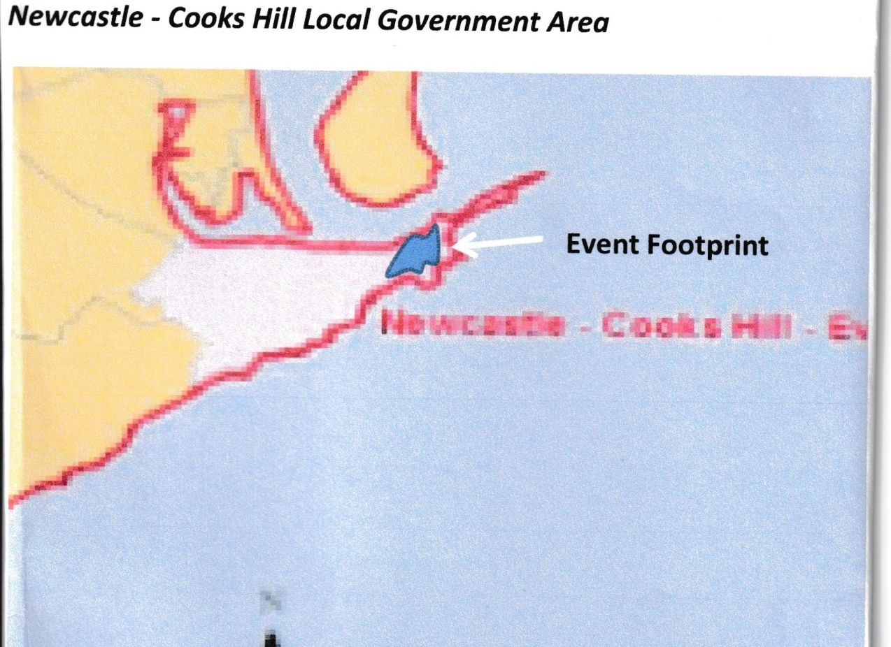
The Herald article summed up the discrepancy as follows:
If the crowd figure (Supercars attendance claim) is correct, the phone data suggests only 158 people were in the rest of the “event space” over the three days of the race. The five suburbs house more than 10,000 residents and thousands of workers, and the analysis shows 114,000 people were in the area in a three-day weekend in May.
Supercars then went on to claim similarly inflated figures in 2018 and 2019.
The HRFC calculation of benefits was itself severely criticized at the time by Professor Aisbett, an international expert in Information Systems. She was the inaugural Professor of Applied Computing at the University of Tasmania and later, the inaugural Professor of Information Systems at the University of Newcastle where she was involved with many initiatives to build the Information Technology industry in Australia. She established a cross-Faculty School of IT at Newcastle, and as Honorary Professor with Uganda’s University of Makerere she assisted its Faculty of Computing & IT with an ambitious post graduate research program.

The Executive summary of her report reads:
The direct benefit of the Newcastle 500 Supercars event claimed in the HRF Centre Report appears to exceed the actual benefit by more than 50%. The Report ignores tourism statistics specific to the Newcastle LGA; it misuses valuable data on average expenditure in the Newcastle LGA; it inappropriately selects a cold-snap May weekend as counterfactual; it does not account for Supercars visitors finding accommodation in neighbouring LGAs; and it neglects the impact of the event on international tourists. Finally, the Report’s use of Telstra data in which visitor counts apply to the Newcastle-Cooks Hill statistical area rather than to the entire Newcastle LGA handicaps its analysis of the benefit of the event to the Newcastle LG
Professor Aisbett pointed out that the May week-end chosen by CN and Telstra as the “normal” week-end was 70% below the average week-end for that year, hence the visitor uplift was greatly inflated. The HRFC report also assumed that all overnight visitors stayed in Newcastle LGA when many stayed in Port Stephens and Lake Macquarie
It is also notable that the benefits claimed in the HRFC Report did not take into account the considerable costs of staging the event.
In 2021, council decided to ignore the HRFC Report altogether and contracted Ernst and Young to do another economic impact calculation of the 3 events. This assessment of benefits relied totally on the grossly exaggerated attendance data given them by Supercars - at all 3 events. Moreover, ALL those claimed to visit Newcastle for the event were assumed to stay 1.8 nights in Newcastle LGA.
To date both state and local government agencies continue to ignore the truth about attendance figures and economic impact caused by the event.
Health and Safety Issues
When agreeing to stage the Newcastle 500, the elected councillors were told that the circuit would abide by international safety standards. It does not. As a temporary circuit it is simply left to the discretion of the safety officers in the governing body of motorsport in Australia for approval. In 2017 this was the Confederation of Australian Motorsport (CAMS). It is now Motorsport Australia.
When CAMS licensed the circuit back in 2017, its Track Safety Advisory Committee was headed by the ex-Supercars driver who helped design the track, Mark Skaife! This committee also included David Stuart, who until recently was Supercars Sporting and Technical Director who became CAMs Division Manager-Safety and Race Operations.
This clear conflict of interest resulted in a circuit which is unsafe. Spectators trackside, and residents who actually live on the circuit, are in danger of flying debris. This is because there is insufficient distance between the circuit safety fence and viewing areas and people’s homes. According to the CAMS Safety Guide, the 3rd line of protection (the spectator fence) should be 1.2 metres high and 3 metres from the 1st & 2nd lines of protection (on the track edge). At Newcastle, the fence is only 1.2 metres high and can’t be moved back the required distance because 50% of this track is lined by buildings. Unlike internationally recognised circuits, there are no grassy verges to slow down flying debris. Flying tyres and car-body shrapnel are a common occurrence at motorsport events.
Safety incidents have occurred during each Newcastle event. A flying tyre injured 2 spectators during the 2017 event. 2 spectators leaned out over the track through a gap in the fencing to take ‘selfie’ photos. NERG has photographs of a piece of mudguard that flew over the safety fence in 2018, narrowly missing a young boy walking behind his parents. During 2019, 2 drunken spectators had no problem scaling the safety fence and sitting astride it during the finale, with cars racing a few metres below. Safety breaches are common on the Newcastle circuit.
The authority for the event, Destination NSW, appointed Supercars themselves to investigate these breaches in public safety. The public were simply assured by Supercars that these incidents were unusual and unlikely to re-occur.
The ease of access for support services (needed by the elderly people living in the 4 Department of housing complexes inside the circuit) is severely impacted by the location of the race in a residential precinct. The event also requisitions emergency ambulances and fire services that would normally be available city-wide.
Sound levels have been proven to be hazardous. Supercars own Noise Monitoring Report was inadequate in its scope and mitigation strategies. In June 2018, PCCD (Pollution Control Consultancy and design) peer reviewed Jacob’s Noise Monitoring Report carried out during the 2017 event on behalf of Safework. Their executive summary reported:
In short, in PCCD's opinion, the monitoring of noise during the inaugural Newcastle 500 held on 24-26 November 2017 did not collect essential information on the noise impact of future Newcastle 500 events during the next 5 years, because this monitoring did not:
l. Determine the highest [exceeding 140 dB(C)] C-weighted, peak sound pressure level (L6pss) due to inadequate measuring instrumentation; and
2. Cover the entire race circuit
PCCD concluded that:
“We are quite alarmed that the C-weighted peak sound level may (or will) exceed 140 dB(C). Page 9 of the Noise Management Plan states the commonly accepted view that any exposure above this peak may cause almost instant damage to hearing. Yet, later on, the Noise Management Plan predicts that the peak may exceed this dangerous level at a number of properties in Zaara St, Scott St and Watt St, reaching up to 150 dB(C) and then appears comfortable with controlling such levels with personal hearing protectors (earplugs). “
Councillors need to carefully consider these serious issues before making a decision to support the extension of the Newcastle 500 contract for another 5 years. To date there has been no consideration for the eleven-week long period of disruption to the city and the substantial costs of the event in social, environmental and economic terms. At the very least, if council is genuine about further consultation with those impacted by the event, an independent survey needs to be done using real, verifiable evidence derived directly from the community and businesses affected. And it MUST be balanced against a fully itemised account of costs.

